**Statistical Summary of Survey Monkey**

Participation in the survey was strong (219 respondents) and captured a diverse cross-section of library usage patterns



There is great consistency among respondents of what the most important functions of the library are.

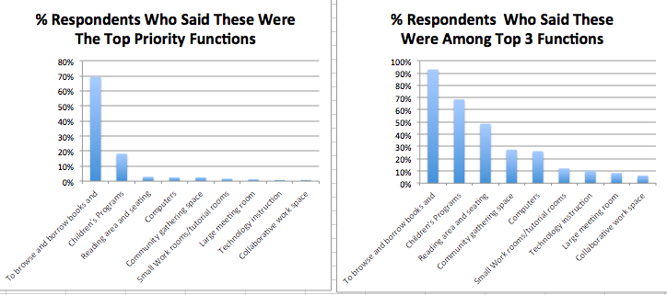

Generally speaking, the mission statements were probably not sufficiently differentiated to produce clear conclusions on the preferences for TML:



Using Offsite Locations for new programs not capable of being housed in TML were clearly supported.

